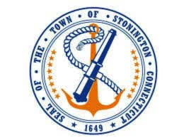
Town of Stonington
Communications Summary
2021

In 2020, the Board of Selectmen appointed members of the Public Communications Ad Hoc Committee with the objective to help improve communication with residents on municipal matters.
The Committee, working in partnership with the First Selectman, produced the following outcomes:
- A summary overview of all Town communication channels, which has been publicly shared on the website in a Communication Inventory mapping document.
- Based on research from other Towns and best practices input from Sustainable CT, produced a first ever Communication Strategy for the Town of Stonington.
- New ‘Town Communication’ tab on the Town Homepage.
  - Within that page, the Communications Inventory, which provides an overview of all Town communication channels was published here.
  - We also provided a reminder that people can sign-up to receive email updates for Board and Commission meetings, as well as Town news from various departments such as First Selectman, Tax, Public Works and Police. And if you decide that you no longer want to receive notices, you can remove your name from the list. See more here.
- Created and put forward a Communication Survey to gain better understanding from residents on how they currently are receiving information and how it could improve.
- Based on the results of that survey, the Committee is being asked to issue a final recommendation on a potential Town Newsletter, including its content and frequency.
  - Based on the discussion at the September meeting, this summary document will be updated to reflect the committee’s decision and the First Selectman will be tasked with taking that work forward.

