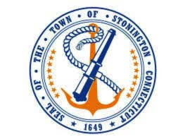
Town of Stonington
Communications Strategy- Survey Results
2021

Introduction
The Communication Task Force in partnership with the First Selectman put forward a survey regarding the Town’s Communication with residents in order to gain a better understanding of how the community is currently receiving information from the Town and how the Town may be able to improve its communication. This is in line the Town’s newly stated Mission:
To offer transparency in local government, by providing a diverse range of communication channels for the Stonington community. Striving to effectively communicate the work of Town departments, Boards and Commissions, and relevant community information.
Summary of Responses
- 142 people responded to the survey, 95% described themselves as full-time residents.
- Awareness of Communication Channels:
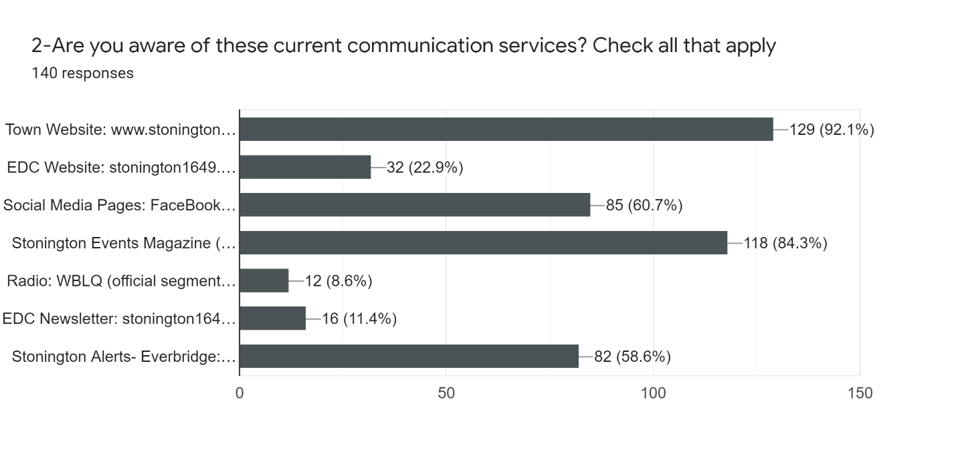
- 66.7% of respondents wanted a one stop, focused communication option found in one location.
- 82.4% of responders said they would find an emailed newsletter useful. 64% said it should be monthly and only 9% said weekly. 27% said Quarterly.
- Newsletter content:
  - 97.7% said summary of Town projects
  - 88.5% summary of Board/Commission activities
  - 84.6% summary of Economic Development information
  - 67.7% said information from other businesses and nonprofits.

